

**Year 12 General Biology**

**Task 3: Reproduction Test**

**Answer Booklet**

**Name: ______________________________________________**

**Form: __________________ Date: _________________**

Time Allocated: 60 minutes

Weighted: 17%

**Multiple Choice Short Answer Extended Answer Total**

**/37**

**/13**

**/10**

**/60**

**SECTION 1 MULTIPLE CHOICE ANSWERS**

Please circle the correct answer for each of the multiple choice questions below.

|  |  |  |  |  |
| --- | --- | --- | --- | --- |
| 1 | a | b | c | d |
| 2 | a | b | c | d |
| 3 | a | b | c | d |
| 4 | a | b | c | d |
| 5 | a | b | c | d |
| 6 | a | b | c | d |
| 7 | a | b | c | d |
| 8 | a | b | c | d |
| 9 | a | b | c | d |
| 10 | a | b | c | d |
| 11 | a | b | c | d |
| 12 | a | b | c | d |
| 13 | a | b | c | d |

**Multiple Choice Questions:**

1. The key event in the life cycle of an organism that relates to the **survival** of the species is:

1. a) birth.
2. b) fertilisation.
3. c) growth.

d) reproduction.

|  |  |
| --- | --- |
| 2. Which of the following does **not** undergo asexual reproduction: | |
|  |

1. strawberry
2. b) aphid
3. c) yeast

d) star fish

3. Mitosis is the division of a cell's nucleus into two daughter nuclei. Which of the following statements about mitosis is correct?

1. The two daughter nuclei each carry half as many chromosomes as the

original nucleus.

1. The DNA in each of the daughter nuclei is an identical copy of the DNA in the original nucleus.
2. Each daughter nucleus carries twice as much DNA as the original nucleus.
3. The two daughter nuclei each have twice as many chromosomes as the original nucleus.
4. Which of the following statements about cell division is correct?
5. Mitosis occurs during asexual reproduction.
6. Meiosis begins immediately after fertilisation.
7. Mitosis explains why three brothers do not look alike.
8. Meiosis involves the mutation of chromosomes.

5. If a plant has 14 chromosomes in its gametes how many chromosomes would be in its somatic cells?

a) 14

b) 7

c) 42

d) 28

6. The following diagram shows a species of flowering plant called a kangaroo paw. It produces a large amount of nectar near the ovary.

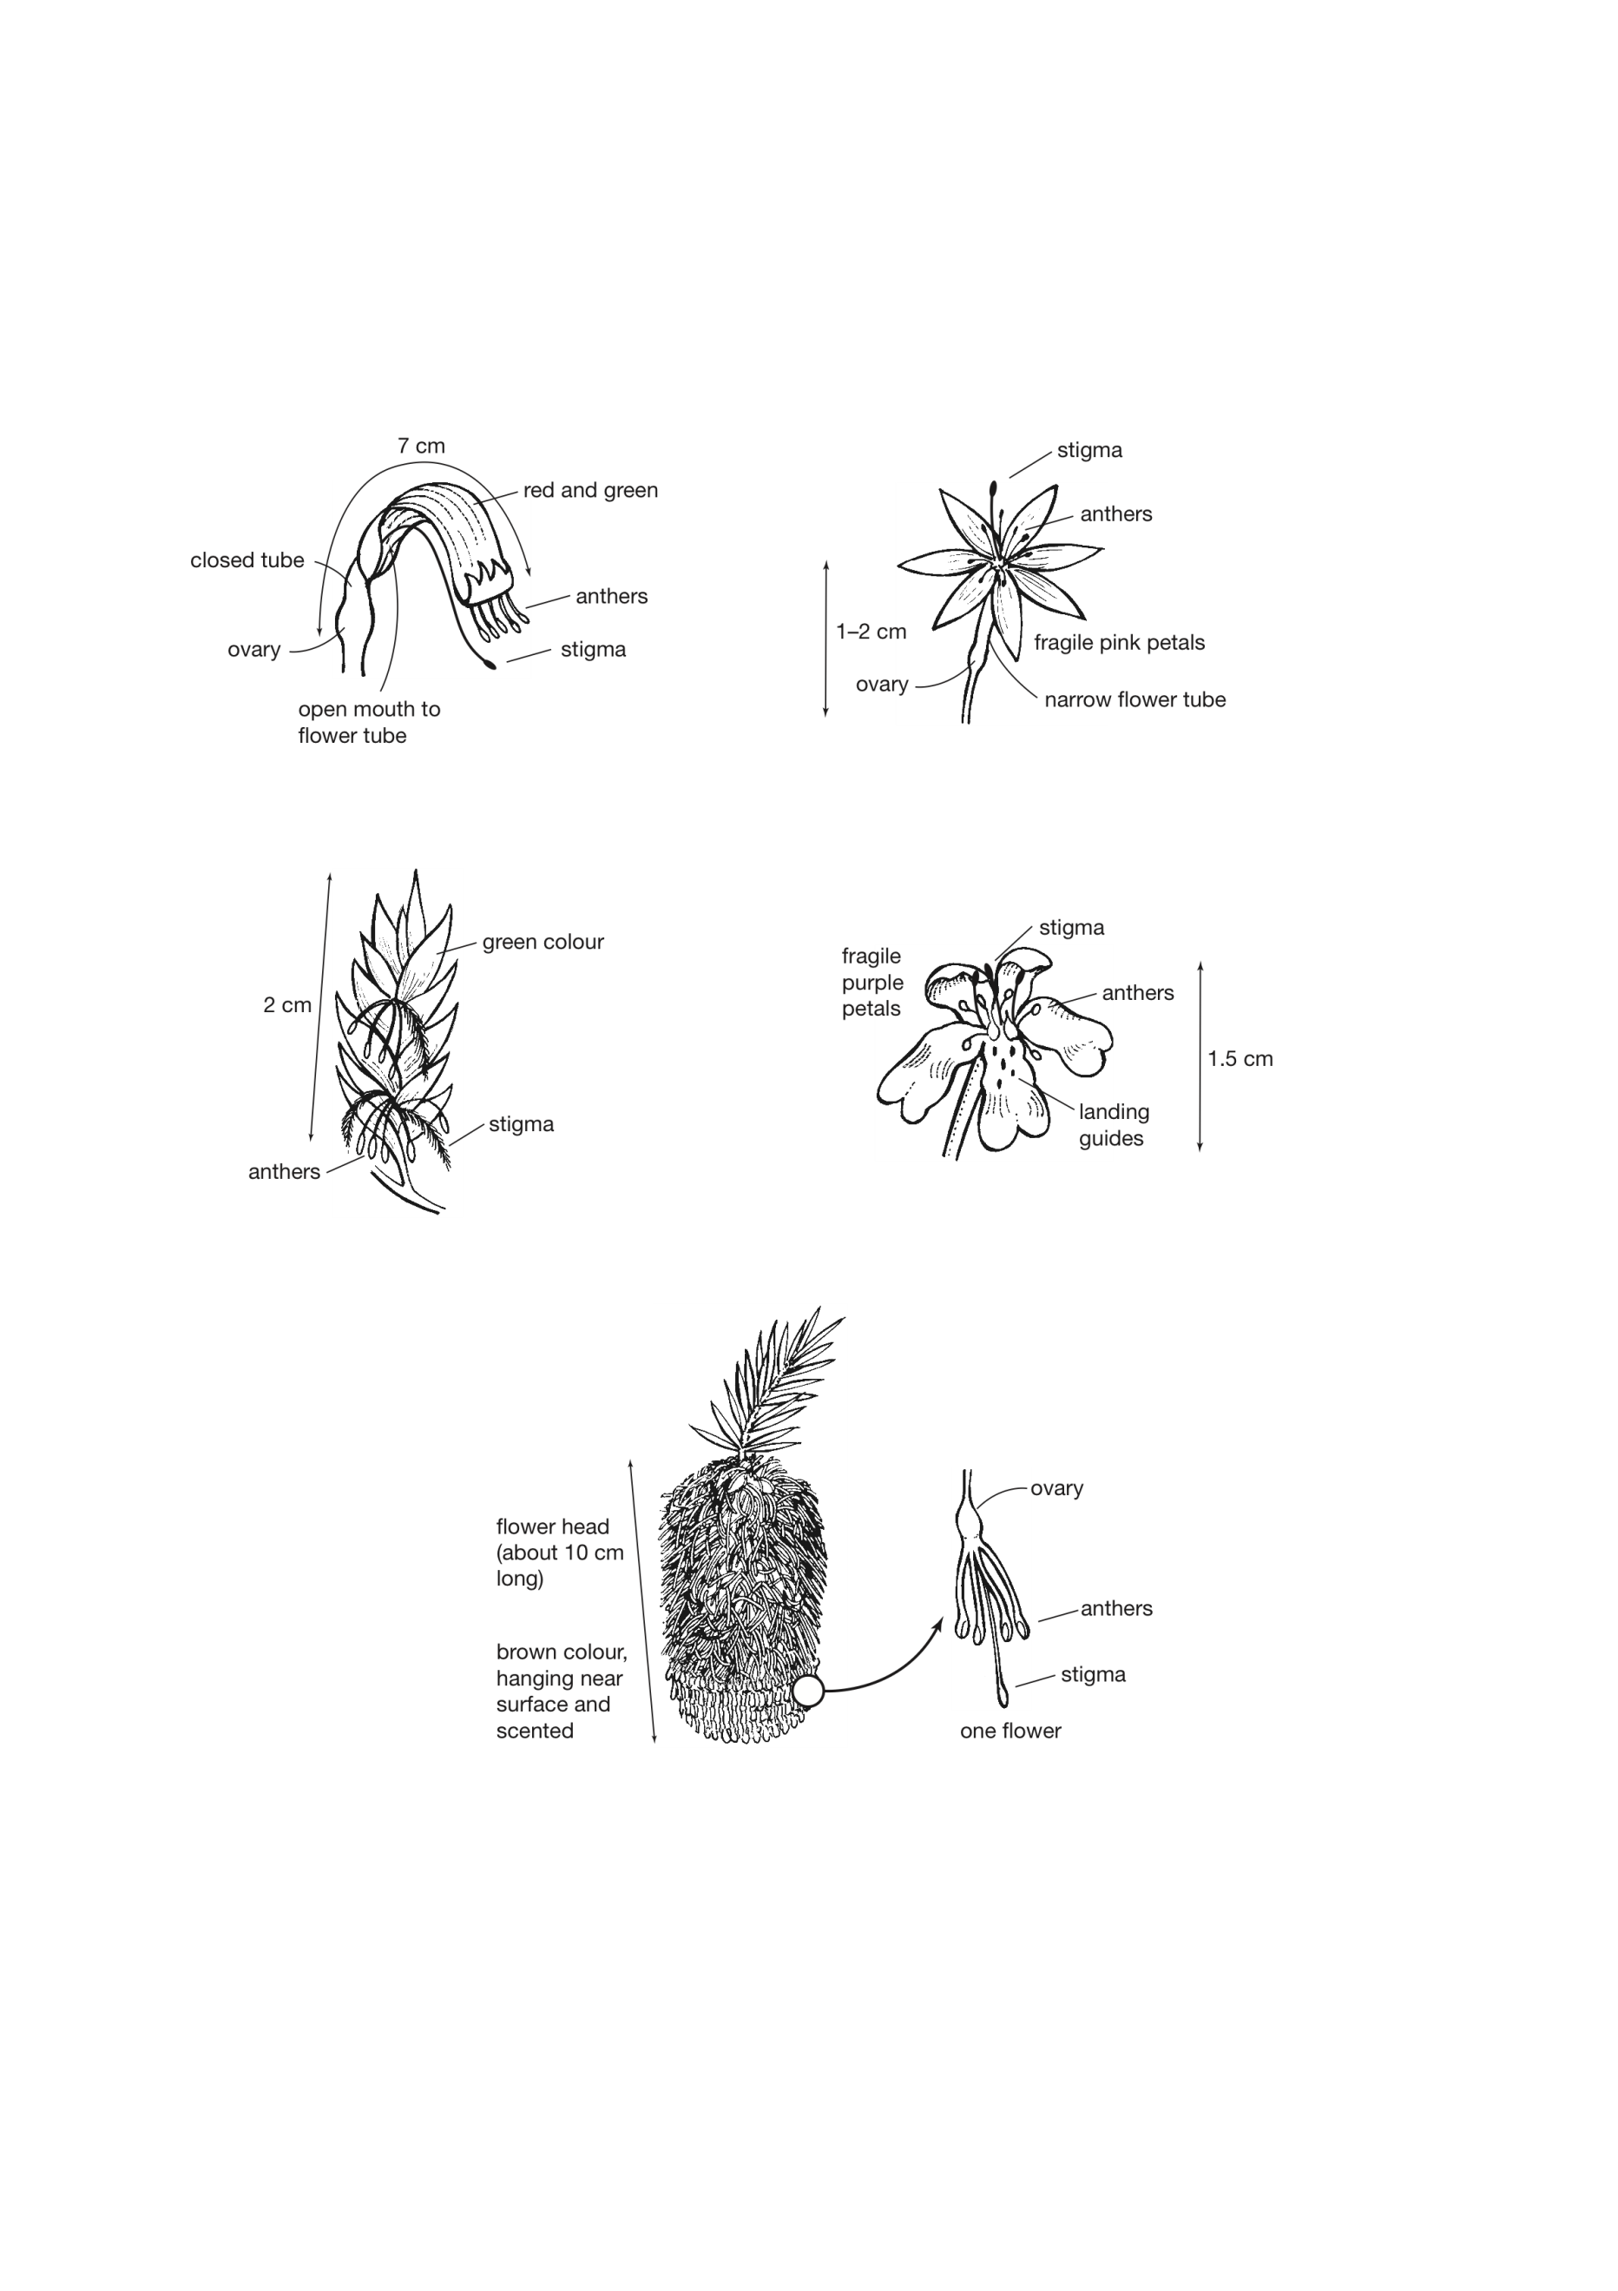

Which of the following predictions is supported by the structure of this flower? The flower is:

a) wind pollinated because the anthers are large, and the flower is brightly coloured

b) self-pollinated because it has the anthers and stigma close together

c) cross pollinated by insects because the flower is large enough to provide lots of food

d) bird pollinated because the anthers and stigma are a long way from the nectar source

7. Which way are the seeds of a dandelion most likely to be dispersed?

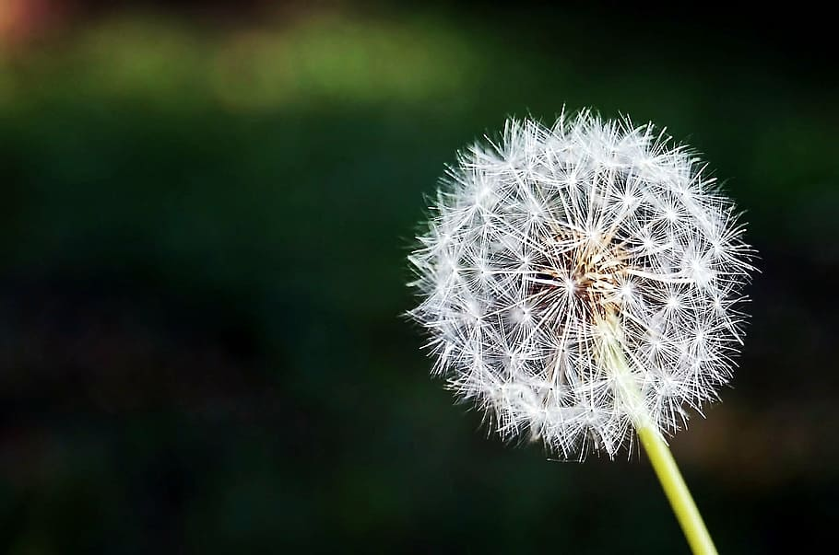

(a) Blown in the wind.

(b) Eaten by animals.

(c) Carried on animals.

(d) Thrown by expulsion.

8. Aphids have separate male and female individuals. Aphids often reproduce by parthenogenesis, during which females produce eggs that turn into young aphids. However, this is an example of asexual reproduction. The explanation for this classification must be that:

a) asexual reproduction involves making eggs.

b) male aphids do not produce sperm.

c) the eggs were never fertilised.

d) aphids do not reproduce sexually.

9. From the following list predict which would result in the greatest amount of variation from reproduction.

a) aphids produced by parthenogenesis from one parent

b) potato plants grown from one parent plant

c) seedlings from the seeds of one flower

d) moss plants grown from one spore case

10. Organisms that employ external fertilisation are more likely to produce large numbers of eggs and sperm. This is because: Top of Form

1. Large numbers of eggs and sperm are more likely to fertilise than smaller numbers.
2. Externally fertilised eggs are usually those of organisms that are tiny and are found in large numbers.
3. Exeternally fertilised eggs are not protected from predators or the environment.
4. It is easier for parents to protect a larger number of developing offspring.

11. Internal fertilisation is a term that refers to:

1. The joining of the sperm and egg inside the female reproductive organs.
2. The joining together of a male and female.
3. The joining of the sperm and egg through the medium of water.
4. Depositing pollen grains on the stigma of a plant.

12. The image below shows the stages of mitosis. The stage labelled A is identified as which of the following:

1. Anaphase
2. Telophase
3. Metaphase
4. Cytokinesis

12. The image below shows the stages of mitosis. The stage labelled B is identified as which of the following:

1. Anaphase
2. Telophase
3. Metaphase
4. Cytokinesis

**B**

A

**END OF MULTIPLE-CHOICE SECTION**

**SECTION 2 SHORT ANSWERS**

13. Complete the following table by describing 1 type of **asexual reproduction** that is and an **example for each:** (6 marks)

|  |  |  |
| --- | --- | --- |
| **Type of asexual reproduction** | **Explanation of how it happens** | **Example of an organism that uses this type** |
| **Budding** |  |  |
| **Fragmentation** |  |  |
| **Binary Fission** |  |  |

14. Complete the following table using the choices in each column. (8 marks)

|  |  |  |  |  |
| --- | --- | --- | --- | --- |
|  | Fertilisation  (external/internal) | Development  (eggs/ live young) | Number of offspring (few/many) | Parental care  (none/some/ extensive) |
| Fish |  |  |  |  |
| Mammals |  |  |  |  |

15. Flowering plants may either be self-fertilised or cross-fertilised. (3 Marks)

A) **Describe** one feature of plants that ensures cross-fertilisation will occur.

B) Explain how this feature allows this.

C) **Clarify** the advantage of cross-fertilisation.

|  |
| --- |
|  |
|  |
|  |
|  |
|  |
|  |

16. **Explain** why organisms that undergo external fertilisation have so many babies compared with those that undergo internal fertilisation. (2 marks)

|  |
| --- |
|  |
|  |
|  |
|  |
|  |
|  |

17. **Discuss** how sexual reproduction restores the diploid number of chromosomes from the haploid number in gametes. (2 marks)

|  |
| --- |
|  |
|  |
|  |
|  |
|  |

18. Label the diagram of the dissected flower below to identify both the male and female reproductive parts. (8 marks)

19. **Compare** and **contrast** meiosis and mitosis in the venn below, **identifying** two similarities and four differences between the two processes. (8 marks)

Meiosis Mitosis

**SECTION 3 EXTENDED ANSWER**

20. What are the three ways that mammals give birth? List and describe each and provide an example species for each. Explain the benefits of one of these types of birth in the survival of the offspring (10 marks)

|  |
| --- |
|  |
|  |
|  |
|  |
|  |
|  |
|  |
|  |
|  |
|  |
|  |
|  |
|  |
|  |
|  |
|  |
|  |
|  |
|  |
|  |
|  |
|  |

**END OF TEST**